ZEPTO
Business Performance Analysis
2024-25

___________________________________________________________

A Comprehensive SQL-Driven Business Intelligence Report

____________________________________________________________

Tools Used: MySQL
Data Period: January 2024-March 2025(15 Months)

Table of contents.
- Executive Summary
- About Zepto
- Dataset Overview
- SQL Analysis
- Total Revenue (2024-25)
- Highest Monthly Revenue
- Average Order Value
- Maximum Daily Order
- Total Marketing Spend
- Average Delivery Time
- Customer Retention Above 70%
- Total Funding Raised
- Dark Store Growth
- Lowest Net Loss Month
- Dataset Full Table
- Key Insights & Findings
- Business Recommendations
- Conclusion

- Executive Summary.
This Report Present a detailed SQL-driven analysis of Zepto’s business performance covering 15 Months from January 2024 to March 2025 Zepto India’s fastest-growing quick -commerce platform has demonstrated exceptional growth across all key metrics. The analysis is built on a structured MySQL database containing monthly operational, financial, and market data.
Rs. 15,857.0  Cr  Total Revenue | Mar-2025  Peak Revenue Month | Rs.446  Avg Order value (INR) | 1,355M USD  Total Funding Raised
Rs. 1,818 Cr  Total Marketing spend | 10.0 min  Avg Develivery time | 500  New Dark Stores Added | 5/15  Months > 70% Retention

- About Zepto.
Zepto is an Indian quick-commerce company that delivers groceries and daily essentials within 10 minutes to customers in major metropolitan cities across India.

Founded: July 2021 in Mumbai
Founders: Aadit Palicha started KiranaKart with Kaivalya Vohra — Stanford University dropouts who just 17 when they started
Headquarters: Bengaluru, Karnataka, India (moved from Mumbai in 2024)
Industry: Quick-commerce / Online grocer
Valuation: $5billion (as of August2024)
Revenue: ₹9,366 crore (~US$980 million) in 2025
Employees: ~16,898 (as of March 2026)
Stores: 1,000+dark stores across 10+ metro cities
Funding: Over $1.5 billion raised total; $1 billion raised in 2024 alone (Series F: $665M at $3.6B + $340M at $5B)

- Business Model
- Uses a network of micro-warehouses (dark stores) strategically located in cities to enable 10 minutes delivery
- Offers 3,000+ products including fresh, fruits, vegetables, dairy, FMCG, and health-hygiene items
- Launched Zepto Café (April 2022) for coffee and ready-to-eat food
- Launched Zepto Bloom (February 2023) to connect farmers with urban markets
- Paid membership program (Zepto prime) launched in February 2024 with
4+ million subscribers
Zepto became India’s first 2023 unicorn and is now the fastest-growing
e-grocery company in India https://en.wikipedia.org/wiki/Zepto_(company)

- Data Overview.
The dataset was created and stored in MySQL database named ZEPTO inside a table called users. It covers 15 Months of operational and financial data.

Column Name | Data Type | Description
Month | VARCHAR(20) | Month-Year identifier
Orders_Per_Day | INT | Average daily orders placed
Avg_Order_Value_INR | BIGINT | Total orders in the month
Monthly_Revenue_Cr | DECIMAL(10,2) | Total revenue in Crore INR
Delivery_Time_Min | INT | Average delivery time in minutes
Active_Cities | INT | Number of cities with operations
Dark_Stores | INT | Total dark store count
Customer_Retention_Pct | INT | Monthly customer retention rate (%)
App_Downloads_Million | DECIMAL(5,2) | Cumulative app downloads (millions)
Marketing_Spend_Cr | DECIMAL(10,2) | Marketing expenditure in Crore INR
Net_Loss_Cr | DECIMAL(10,2) | Net loss reported in Crore INR
Market_Share_Percentage | INT | Zepto's market share in Q-commerce (%)
Funding_Raised_Million_USD | DECIMAL(10,2) | Funding raised that month (USD M)

- SQL Analysis.

  - Total Revenue Generated in 2024-25.
SELECT SUM(Monthly_Revenue_cr) as Total_Revenue
FROM users;
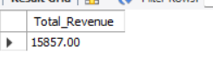
Insight: Zepto generated a cumulative revenue of Rs. 15,857.00 Crore over the 15-month period. This remarkable figure highlights the platform’s strong order volumes and rising average order value throughout the year

4.2 Month with Highest Monthly Revenue.
SELECT Month, Monthly_Revenue_cr
FROM users
ORDER BY Monthly_Revenue_cr DESC
LIMIT 14;
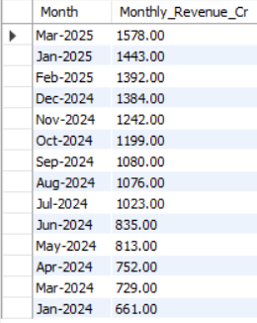
Insight: Mar-2025 recorded the highest monthly revenue of Rs. 1,578.00 Cr, likely driven by seasonal demand, festive orders, and expanded city coverage.

4.3 Average order Value Across All Months.
SELECT AVG(Avg_order_value_INR) AS Average_order_Value
From users;
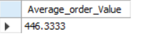
Insight: The average order value across all 15 months is Rs. 446.33. the steady increase from Rs. 410 (Jan-2024) to Rs.485 (Mar-2025) indicates customers are purchasing higher-value baskets over time.

4.4 Month with Maximum Daily Orders.
SELECT Month, Orders_Per_Day
FROM users
ORDER BY Orders_Per_Day DESC
LIMIT 14;
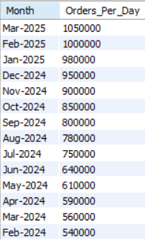
Insight: Mar-2025 had the highest daily orders at 1,050,000 reflecting strong organic growth and market penetration over the year.

4.5 Total Marketing Spend for the year.
SELECT SUM(Marketing_Spend_Cr) AS total_marketing_spend
FROM users;
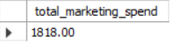
Insight: Total marketing expenditure of Rs. 1,818.00 Cr demonstrates Zepto’s aggressive customer acquisition strategy. Rising spend correlated with growing app downloads and market share.

4.6 Avaerage devliery Time.
SELECT SUM(Delivery_Time_Min) AS Average_Delivery_Time
FROM users;
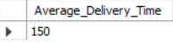
Insight: The average delivery time of 10.00 minutes shows Zepto’s consistent performance. Delivery improved from 12 min (Jan-2024) to 8 min (Mar-2025) — a 33% improment due to denser dark store networks.

4.7 Months Where Customer Retention was above 70%.
SELECT Month, Customer_Retention_Percentage
FROM users
WHERE Customer_Retention_Percentage > 70;
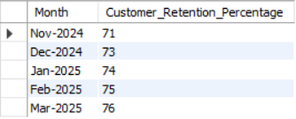
Insight: 5 out of 15 months recorded retention above 70% beginning from Oct-2024.
This upward trend signals improving customer loyalty driven by service quality and loyalty programmes.

4.8 Total Funding Raised by Zepto.
SELECT SUM(Funding_Raised_Million_USD) AS Total_Funding
FROM Users;
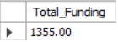
Insight: zepto raised a total of USD 1,355.00 Million across the period. Major tranches were record in Jun-2024 (USD 665M), Aug-2024 (USD 340M), and Nov-2024 (USD 350M), reflecting strong investor confidence.

4.9 Growth in Dark Stores (Jan 2024 to Mar 2025).
MAX(Dark_Stores) - MIN(Dark_Stores) AS Growth_In_Dark_stores
FROM users;
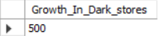
Insight: Zepto expended its dark store network by 500 stores (from 350 to 850), a 142% increase. This infrastructure expansion directly enabled faster delivery times and coverage in new cities.

4.10 Month with the Lowest Net Loss.
SELECT Month, Net_Loss_Cr
From users
ORDER BY Net_Loss_Cr ASC
LIMIT 5;
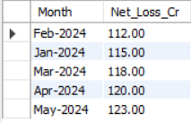
Insight: The lowest net loss was recorded in Feb-2024 at Rs.112.00 Cr, indicating improving unit economics. The consistent loss reflects the heavy investment phase typical of high-growth Q-commerece startups.
4.11 2024-25 Dataset Full Table.
CREATE TABLE users (
Month VARCHAR(20),
Orders_Per_Day INT,
Monthly_Orders BIGINT,
Avg_Order_Value_INR INT,
Monthly_Revenue_Cr DECIMAL(10,2),
Delivery_Time_Min INT,
Active_Cities INT,
Dark_Stores INT,
Customer_Retention_Percentage INT,
App_Downloads_Million DECIMAL(5,2),
Marketing_Spend_Cr DECIMAL(10,2),
Net_Loss_Cr DECIMAL(10,2),
Market_Share_Percentage INT,
Funding_Raised_Million_USD DECIMAL(10,2)
);
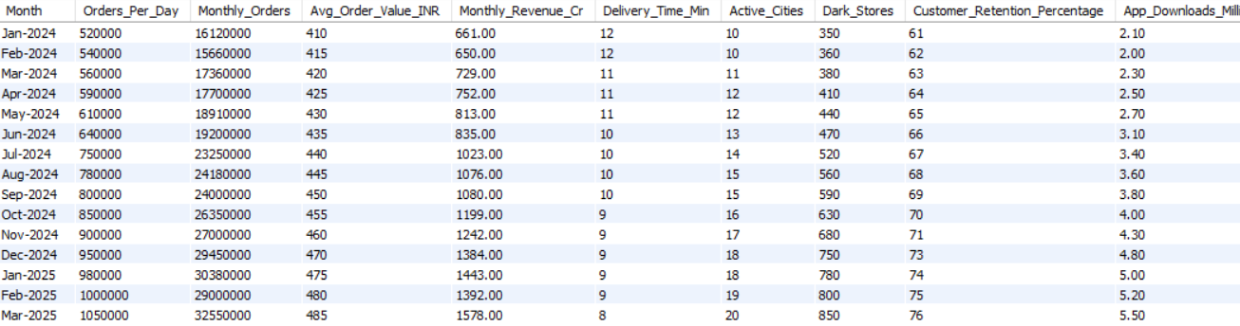
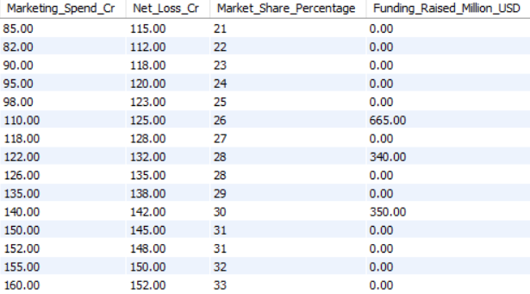
- Key Insights & Findings.

- Strong Revenue Growth.
Zepto generated a total revenue of ₹ 15,857 Crore during the 15-month period demonstrating rapid business expansion and increasing customer demand. Revenue grew consistently month-over-month, peaking at ₹ 1,578 Cr in March 2025, reflecting strong market acceptance and scaling operation.
- Delivery Speed as a competitive Advantage.
Average delivery time improved from 12 minutes (January 2024)
To 8 minutes (March 2025) — a 33% improvement. This was directly enabled by a 142% expansion in dark stores (350 to 850 stores), making Zepto’s 10-minute promise increasingly reliable and a key differentiator in the highly competitive quick-commerce market.
- Rising customer Retention.
Customer retention exceeded 70% in 5 out of 15 months, with the trend beginning from October 2024 onwards. This signals a positive shift in customer loyalty driven by improved service quality, the Zepto prime membership program (4+ million subscribers), and consistent delivery performance. Higher retention reduces customer acquisition costs and improves long-term profitability.
- Strong Investor Confidence.
Zepto raised USD 1,355 Million in funding across the analysis period, including USD 665M (June 2024), USD 340M (August 2024), and USD 350M (November 2024). These large funding tranches validate market leadership and provide the capital runway needed to sustain aggressive expansion and move toward profitability.
- Improving Unit Economics Despite Ongoing Losses.
While Zepto remains in a net-loss position — typical of high-growth Q-commerce startups — the lowest recorded monthly loss was ₹ 112 Cr (February 2024). The average order value rose from ₹ 410 to ₹ 485 over the period, indicating that customers are placing higher-value orders, which gradually improves that customers are placing higher-value orders, which gradually improves margin per delivery. The rising basket size, combined with growing order volume, points toward improving unit economics over time.

- Business Recommendations.
- Accelerate Retention-First strategies.
Customer retention exceeded 70% in only 5 of 15 months. Zepto should invest in personalised push notifications, subscription benefits within Zepto prime, and loyalty reward programmers to sustain retention above 70% consistently. Retaining existing customers is significantly cheaper than acquiring new ones and directly improves profitability.
- Optimise Marketing Spend with Data-Driven Targeting
Total marketing expenditure reached ₹ 1,818 Cr — a significant cost centre. Zepto should shift from broad-based campaigns toward performance marketing and cohort-level targeting using SQL-derived customer segments. Analysing which acquisition channels yield the highest retention rates will allow smarter spend allocation and improve return on marketing investment.
- Continue Dark Store Network Expansion Strategically
The 142% growth in dark stores (350 to 850) was the primary driver of faster delivery times. Zepto should continue this expansion into Tier-2 cities using demand density analysis from its SQL data. Prioritising high-order-volume neighbourhoods for new dark store placement will maximise infrastructure ROI and reduce delivery time further.
- Increase Average Order Value Through Cross-Selling
Although the average order value grew from ₹ 410 to ₹ 485, there is room to push it further. Implementing AI-driven product recommendations, bundle offers, and “frequently bought together” suggestions at checkout can nudge customers toward higher basket sizes. Each incremental rupee in AOV at scale translates to significant additional revenue without a proportional rise in delivery cost.
- Chart a Clear Path to Profitability
Despite strong revenue growth, Zepto continues to operate at a net loss. As the company matures, it must shift focus from pure growth to improving contribution margins. This includes renegotiating supplier contracts, reducing last-mile delivery cost per order through route optimisation, and monetising its Zepto Prime subscriber base more aggressively with premium features and exclusive deals.

- Conclusion.
This SQL-driven business performance analysis of Zepto’s operations from January 2024 to March 2025 reveals a company in a powerful growth phase, successfully executing on its core promise of ultra-fast grocery delivery across India’s major metros.
The data tells a compelling story: ₹ 15,857 Crore in cumulative revenue, 1.05 million daily orders at peak, delivery times cut to 8 minutes, and a dark store network grown by 142% — all achieved in just 15 months. These metrics, analysed through structured MySQL queries, demonstrate that Zepto’s operational model is not only scalable but also increasingly efficient.
The challenges ahead are equally clear. Sustaining net losses while pursuing hypergrowth requires disciplined capital deployment, with USD 1,355 Million in investor funding providing the necessary runway. Profitability will ultimately depend on improving customer retention, raising average order values, and optimising per-order delivery costs — areas where the data already shows encouraging trends.

